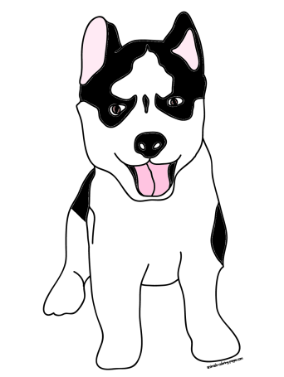**http://api.ning.com/files/gImwTAFeJaqB2g5pUivcoB1Xxs3m1r3MUHnb*vJb9H7qOVrxbveYPMOfyB8kSNtp6chaVSbHt-iwfR0cYWZ3rS*7jta4fHmC/PawPrint.jpgMrs. Segovia’s Daily Schedule**

**Second Grade—Portable 140A**

7:35-7:55 Morning Work, Pledge, Announcements, Housekeeping

8:00-8:30 H.O.W.L Time

8:35-9:45 Math/Guided Math/Math Stations

9:45-11:05 Reading/Guided Reading/Literacy Stations

11:05-11:35 Lunch

11:35-11:55 Recess/Restroom Break

12:00-1:05 Phonics/Writing/Grammar

1:05-1:50 Science/Social Studies

1:50-2:00 Pack Up & Stack Up

2:05-2:50 Specials

2:55 Dismissal

**Special Rotations**

**2:05-2:50**

**Day 1 PE**

**Day 2 Music**

**Day 3 PE**

**Day 4 Computers**

**Day 5 PE**

**Day 6 Music**

**Day 7 PE**

**Day 8 Art**

http://api.ning.com/files/gImwTAFeJaqB2g5pUivcoB1Xxs3m1r3MUHnb*vJb9H7qOVrxbveYPMOfyB8kSNtp6chaVSbHt-iwfR0cYWZ3rS*7jta4fHmC/PawPrint.jpg